

PATIENT INTRODUCTION Today’s Date: ________/_______/________

Name: ______________________________________________ M F Birthdate: ____/____/____ Age: ____________

Address: ___________________________________ City: __________________________ State: __________ Zip: ____________

Cell #: (________) ________ - __________ Email: __________________________@ _______________________________

single married separated divorced widowed

SPOUSES NAME: ________________________________ NUMBER OF CHILDREN: ________________________

WHOM MAY WE THANK FOR REFERRING YOU: _______________________________________________________________

Occupation: ________________________________ Not Employed Part-Time Student Full-Time Student Retired

Briefly describe the reason for your visit: ____________________________________________________________________

DO YOU HAVE A HISTORY WITH ANY OF THE FOLLOWING? IF YES, PLEASE CHECK ALL THAT APPLY

Neck Pain Pacemaker Psychiatric
Low Back Pain Arthritic Disease Arm/Leg Numbness
Osteoporosis Vertigo/Dizziness Diabetes
Surgery Sports Injury Autoimmune Disease
Headaches Disc Bulge Sciatica
Recent Weight Loss Medication Spinal Fusion
Cancer Kidney Stones Major Trauma
Stroke Scoliosis Cardiovascular
Recent Weight Gain Genitourinary Asthma
Skin Disease ADD/ADHD Respiratory Disease
GI Disease Ear Infections Breast Augmentation
Allergies Auto Accident Other _______________

Are you pregnant? NO YES, my due date is: _______/________/________

Have you ever been treated by a chiropractor before? NO YES, with whom? ____________________________

Is this condition due to an accident? NO Yes, Date: ________/________/________

Type: Auto Work Home

To whom have you made a report of your accident? Auto Insurance Employer Worker Comp Other

Do you have health insurance? No Yes, what company? ________________________________________________

In case of an emergency, whom shall we contact?

Name: _______________________________ Relationship ________________________ Phone (_______) __________________
NAME____________________________________ DATE: ______/______/______ 

When did the symptoms BEGIN? GRADUAL SUDDEN ACCIDENT AUTO WORK UNKNOWN

How Long have you had your SYMPTOMS? PAST FEW DAYS PAST WEEK OR SO PAST MONTH

PAST FEW MONTHS PAST YEAR PAST FEW YEARS PAST YEARS+

Are your SYMPTOMS? GETTING WORSE GETTING BETTER NO CHANGE

How bad does it hurt? Please circle one (NO PAIN) 0 1 2 3 4 5 6 7 8 9 10 (WORST PAIN IMAGINABLE)
BACK
FRONT

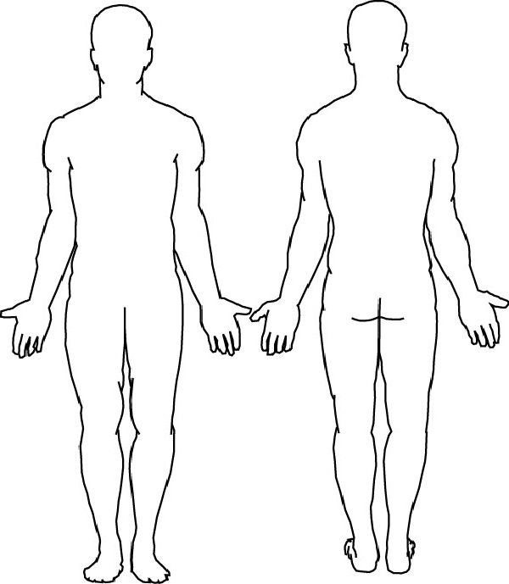
Pain is WORSE IN THE:

MORNING EVENING AFTERNOON THROUGHOUT THE NIGHT

MADE WORSE WHEN:
BENDING/TWISTING CARRYING COUGHING

DRIVING EXERCISING KNEELING LIFTING

LYING/SLEEPING STANDING WALKING

WORKING SITTING OTHER ____________________________

Pain is BEST IN THE:

MORNING EVENING AFTERNOON THROUGHOUT THE NIGHT

MADE BETTER WHEN:
L
R
R
L

NOTHING MEDICATION EXERCISE

HEAT ICE MASSAGE MOVEMENT

REST STRETCHING STANDING

SITTING

PLEASE MARK WHERE YOUR PAIN IS LOCATED AND RADIATES TO
DESCRIPTION of your pain or symptoms:

ACHING PINCHING BURNING NUMBNESS
SWELLING DEEP SHARP
CRAMPING SHOOTING DULL
THROBBING STIFFNESS TINGLING
RADIATING TIGHTNESS

FREQUENCY:

RARELY (1%-10%) OCCASIONAL (11%-25%) INTERMITTENT (26%-50%)
FREQUENT (51%-75%) PERSISTENT (76%-99%) CONSTANT (100%)

YOUR CHIEF COMPLAINT IS: MILDLY SLIGHTLY MODERATELY SEVERELY affected by doing the following:

SITTING BATHING USING STAIRS STANDING TOILET USE
LAUNDRY GROOMING IN/OUT OF BED HOUSEKEEPING DRESSING
IN/OUT OF CAR SHOPPING EATING MEAL PREP USING PHONE
WORKING SLEEPING

PREVIOUS CARE FOR YOUR CURRENT COMPLAINT:

CHIROPRACTIC MASSAGE MEDICAL DOCTOR E.R ORTHOPEDIST NEUROLOGIST FAMILY DOCTOR

PHYS. THERAPY ACUPUNCTURE BED REST MRI CT SCAN SURGERY RX. PAIN KILLERS

OTC PAIN MEDS COLD PACKS HOT PACKS SPINAL SURGERY SPINAL FUSION INJECTIONS

MUSCLE RELAXANTS

PATIENT SIGNATURE: ___________________________________________________________ DATE: ___________________

